Project Design Phase-I

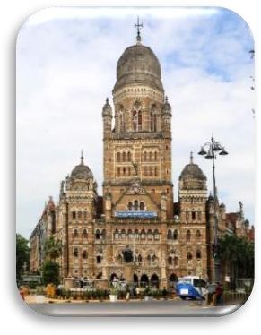

**GSM Module**

**Municipal Corporation**

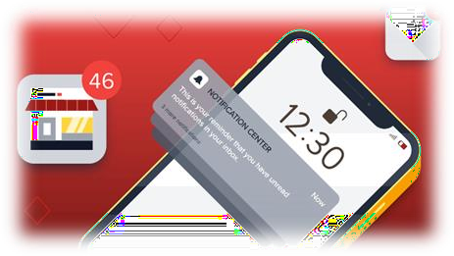

**Navigation system**

# Solution Architecture

|  |  |
| --- | --- |
| Date | 11 October 2022 |
| Team ID | PNT2022TMID44517 |
| Project Name | Project – Smart Waste Management system for Metropolitan cities |
| Maximum Marks | 4Marks |

**Solution Architecture:**

* The general architecture which uses the cluster of smart waste bins connected through IoT in the outdoor environment. It uses a GPS to communicate the status of the smart waste bins enabling the effective waste management system.
* The proposed system could be considered as a robotic smart waste bin where the bins could mobilize, localize its location and communicate its status to the cloud.
* The smartness is achieved by having ultra sonic sensors, Node MCU, Capacitive sensors, servomotors, microcontrollers integrated to form an autonomous system.

# Solution Architecture Diagram:

